PartnerConnect ↔ Merchant360 Integration Services

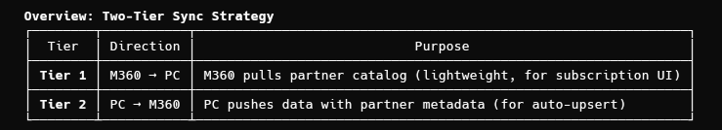
TIER 1: M360 Pulls from PartnerConnect

Endpoint: GET /api/v1/partners

Purpose: M360 pulls the partner catalog to display available suppliers for merchant subscriptions.

Authentication: OAuth2 Bearer Token (or API Key)

Response:
[
{
"id": 1,
"code": "SPR",
"name": "SPR (Sports Parts Retailer)",
"description": "Premium sports equipment distributor",
"logoUrl": "https://cdn.partnerconnect.com/logos/spr.png",
"hasPriceData": true,
"hasEnhancedContent": true,
"isActive": true
}
]

Endpoint: GET /api/v1/partners/{id}

Purpose: Get specific partner details.

Response: Same structure as above (single object).

---
TIER 2: PartnerConnect Pushes to M360

1. Price Updates

PC calls M360: POST /api/v1/partner-connect/merchants/{merchantId}/prices/batch

Payload:
{
"tradingPartner": {
"partnerConnectId": 1,
"code": "SPR",
"name": "SPR (Sports Parts Retailer)",
"description": "Premium sports equipment distributor",
"logoUrl": "https://cdn.partnerconnect.com/logos/spr.png"
},
"items": [
{
"sku": "SPR-12345",
"cost": 49.99,
"listPrice": 79.99,
"currencyCode": "USD"
}
]
}

M360 Expected Response:
{
"success": true,
"updatedCount": 150,
"skippedCount": 2,
"errorCount": 0,
"errors": null
}

---
2. Inventory Updates

PC calls M360: POST /api/v1/partner-connect/merchants/{merchantId}/inventory/batch

Payload:
{
"tradingPartner": {
"partnerConnectId": 1,
"code": "SPR",
"name": "SPR (Sports Parts Retailer)",
"description": "Premium sports equipment distributor",
"logoUrl": "https://cdn.partnerconnect.com/logos/spr.png"
},
"items": [
{
"sku": "SPR-12345",
"quantityAvailable": 100,
"quantityOnOrder": 50,
"warehouseCode": "EAST"
}
]
}

M360 Expected Response:
{
"success": true,
"updatedCount": 150,
"skippedCount": 0,
"errorCount": 0,
"errors": null
}

---
Subscription Management (PC ↔ M360)

PC manages subscriptions by calling M360 APIs:
Method: GET
M360 Endpoint: /api/v1/partner-connect/subscriptions
Purpose: List subscriptions (filter by status, tenantId, tradingPartnerId)
────────────────────────────────────────
Method: GET
M360 Endpoint: /api/v1/partner-connect/subscriptions/{id}
Purpose: Get subscription details
────────────────────────────────────────
Method: POST
M360 Endpoint: /api/v1/partner-connect/subscriptions
Purpose: Create new subscription request
────────────────────────────────────────
Method: POST
M360 Endpoint: /api/v1/partner-connect/subscriptions/{id}/approve
Purpose: Approve subscription
────────────────────────────────────────
Method: POST
M360 Endpoint: /api/v1/partner-connect/subscriptions/{id}/deny
Purpose: Deny subscription
────────────────────────────────────────
Method: POST
M360 Endpoint: /api/v1/partner-connect/subscriptions/{id}/suspend
Purpose: Suspend subscription
────────────────────────────────────────
Method: POST
M360 Endpoint: /api/v1/partner-connect/subscriptions/{id}/reactivate
Purpose: Reactivate subscription
Subscription DTOs

Create Subscription Request:
{
"tenantId": 123,
"tradingPartnerId": 1,
"accountNumber": "ACCT-001",
"notes": "Optional notes"
}

Subscription Response:
{
"id": 1,
"tenantId": 123,
"tenantName": "ABC Dealer",
"tenantCode": "ABC",
"tradingPartnerId": 1,
"tradingPartnerCode": "SPR",
"tradingPartnerName": "SPR (Sports Parts Retailer)",
"accountNumber": "ACCT-001",
"status": "Approved",
"requestedAt": "2026-05-15T10:00:00Z",
"approvedAt": "2026-05-15T12:00:00Z",
"approvedByUserId": 5,
"approvedByUserName": "Admin User",
"denialReason": null,
"notes": null,
"suspendedAt": null,
"suspendedByUserId": null,
"suspendedByUserName": null
}

---
Data Models
TradingPartnerInfo (included in all push payloads)
record TradingPartnerInfo(
int PartnerConnectId, // PC's internal ID
string Code, // e.g., "SPR"
string Name, // Display name
string? Description, // Optional description
string? LogoUrl // Optional branding
);
Subscription Status Enum
Pending | Approved | Denied | Suspended

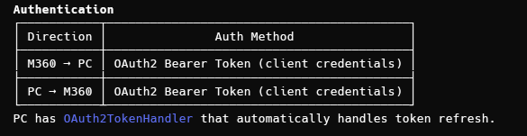
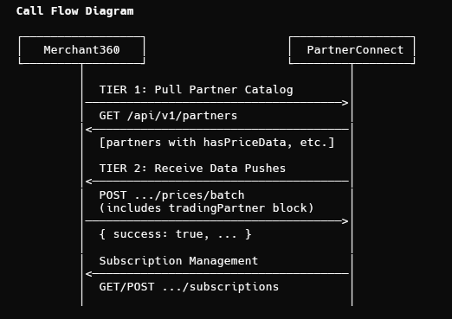
Key Implementation Notes for M360 Developer

1. Partner Upsert: When receiving price/inventory pushes, M360 should upsert the tradingPartner block to maintain a local partner record.
2. Data Availability Flags: The hasPriceData and hasEnhancedContent flags indicate whether PC has data loaded for that supplier - useful for UI display.
3. OAuth2 Tokens: Both sides use client credentials flow. PC's token handler auto-refreshes.
4. Subscription Workflow:
- Merchant requests subscription in M360 UI
- M360 calls PC to create subscription
- PC admin approves/denies
- On approval, PC starts pushing data for that merchant/partner combo

